**Dynamic Design**

**By: Hassan Mahmoud**

**ECU 1**

**Components State Machine Diagram**

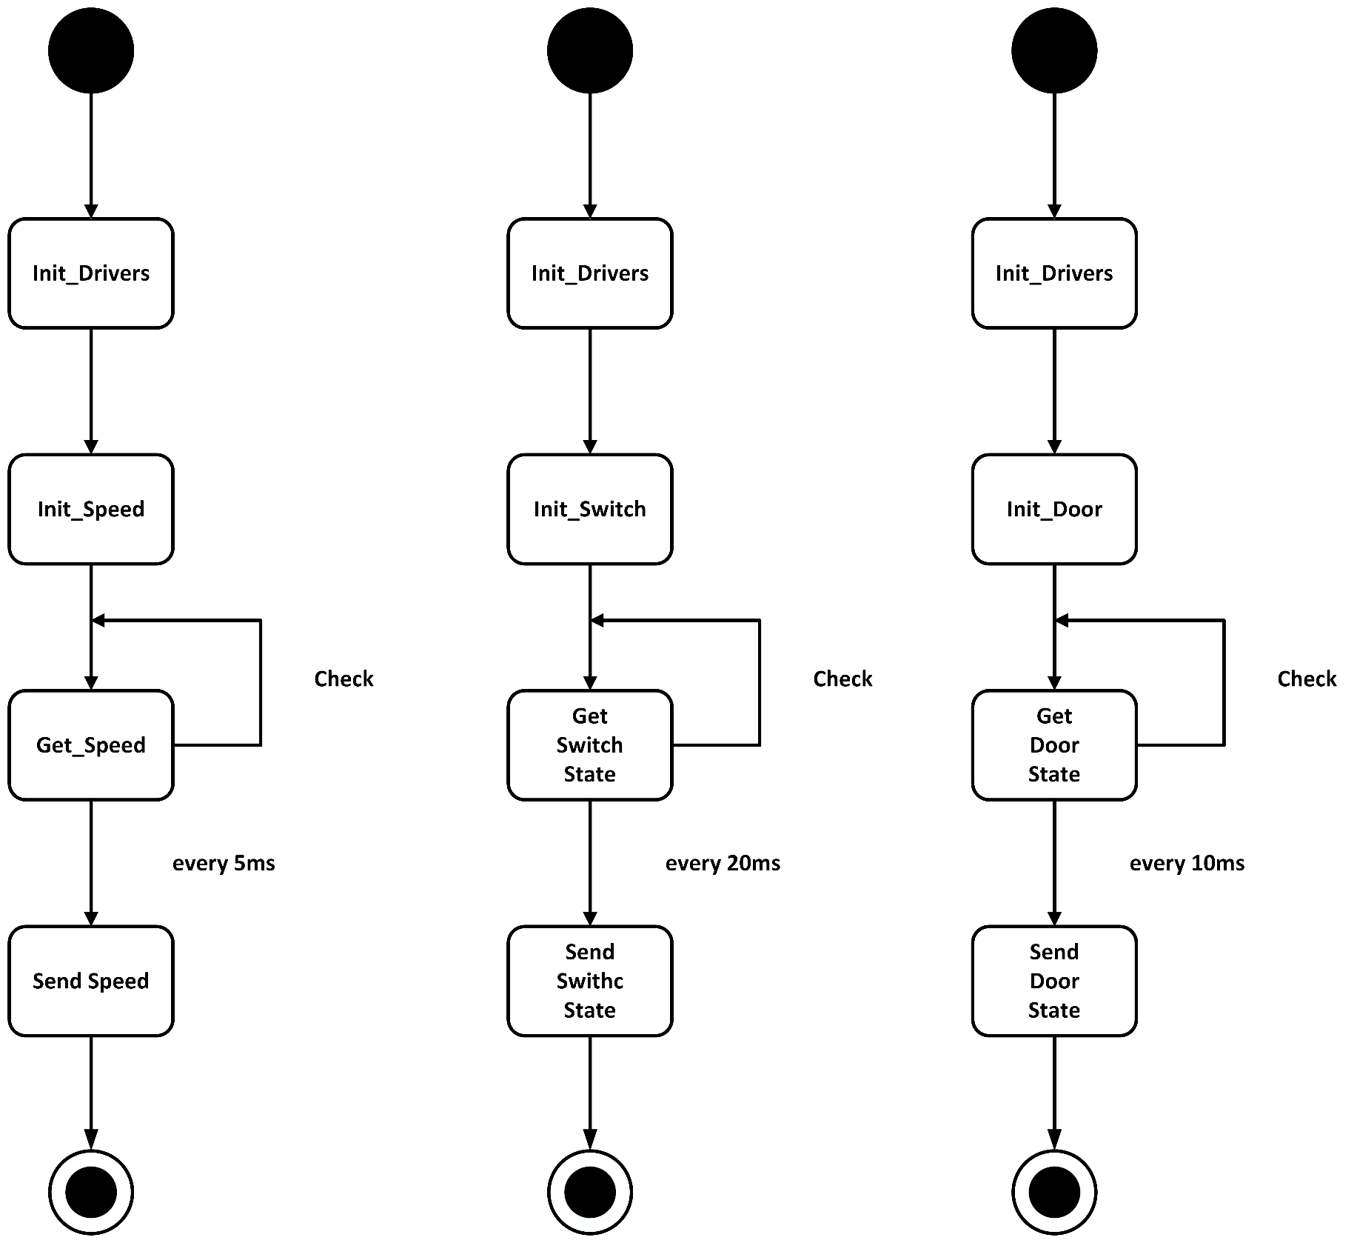

Figure : State Machine Diagram for ECU1 components

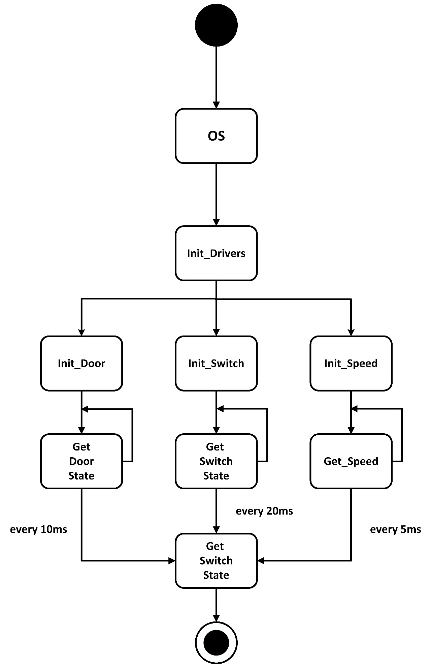

Figure : State Machine Diagram for ECU1 Operation

**Operation State Machine Diagram**

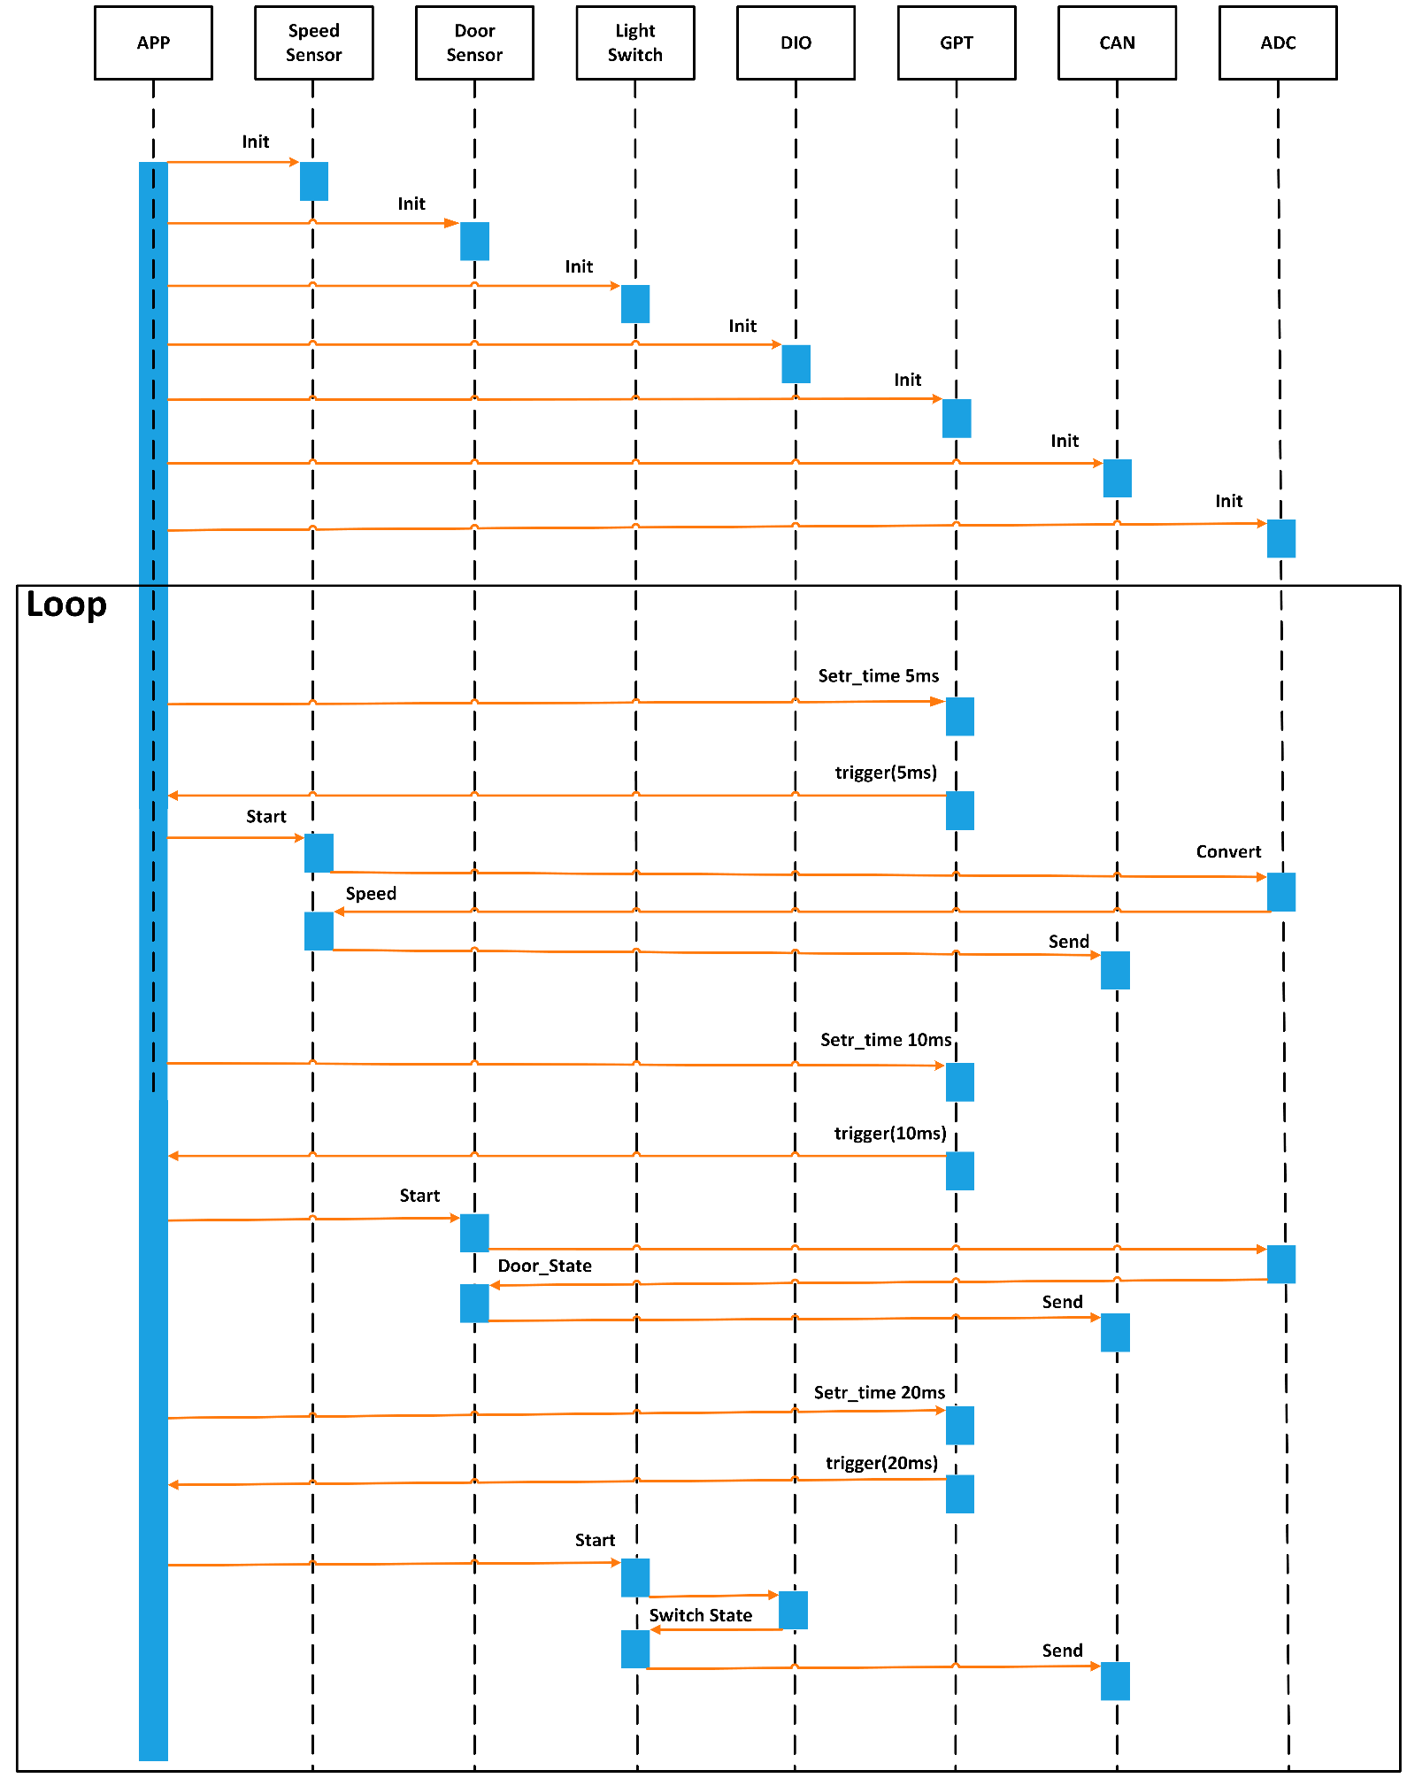

Figure : Sequence Diagram for ECU1

**Sequence Diagram**

**CPU Load Calculation**

**o Utilization = Total Execution Time During Hyperperiod / Hyperperiod**

**o Utilization = ((1 ∗ 2) + (1 ∗ 1) + (1 ∗ 4) / 20) * 100% = 35%**

**ECU 2**

**Components State Machine Diagram**

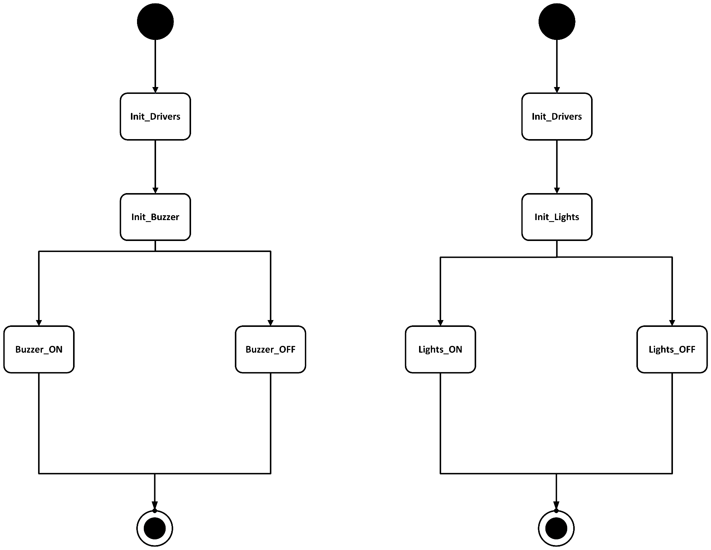

Figure : State Machine Diagram for ECU2 Components

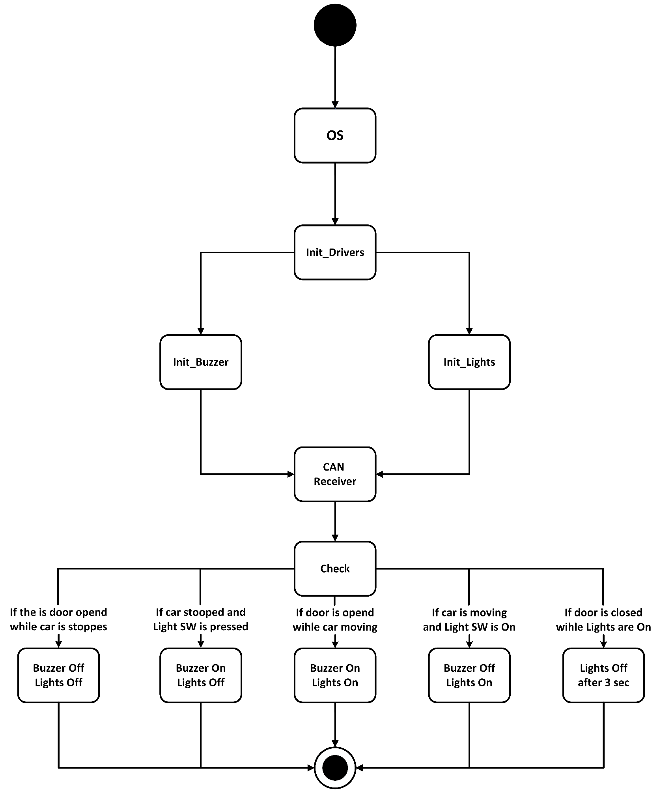

Figure : State Machine Diagram for ECU2 Operation

**Operation State Machine Diagram**

**Sequence Diagram**

Figure : Sequence Diagram for ECU2

**CPU Load Calculation**

**o Utilization = Total Execution Time During Hyperperiod / Hyperperiod**

**o Utilization = ((1 ∗ 3) /10) * 100% = 30%**

**BUS Load Calculation:**

we have below multiple sending intervals on the bus as:

1 frame every 5 ms = 200 frames every 1000 ms

1 frame every 10 ms = 100 frames every 1000 ms

1 frame every 20 ms = 50 frame every 1000 ms

This is in total 350 frames every 1000 ms

Total time on bus is 350 * 250 µs

Total time is 1000 ms = 1000 * 1000 µs

**Bus load is                 ((350 * 250) / (1000 * 1000)) * 100 % = 8.75 %**